If yes, the Bot guide then the prompts below begin

If explore on their own then the Bot says “Great, if you want my assistance start a conversation with me in the Veye Bot. A good place to start are the Progress Trackers

If guide the Bot then says “It is helpful to have a way to track your progress. The best way is through blood tests. Do you have any recent lab results you can enter?

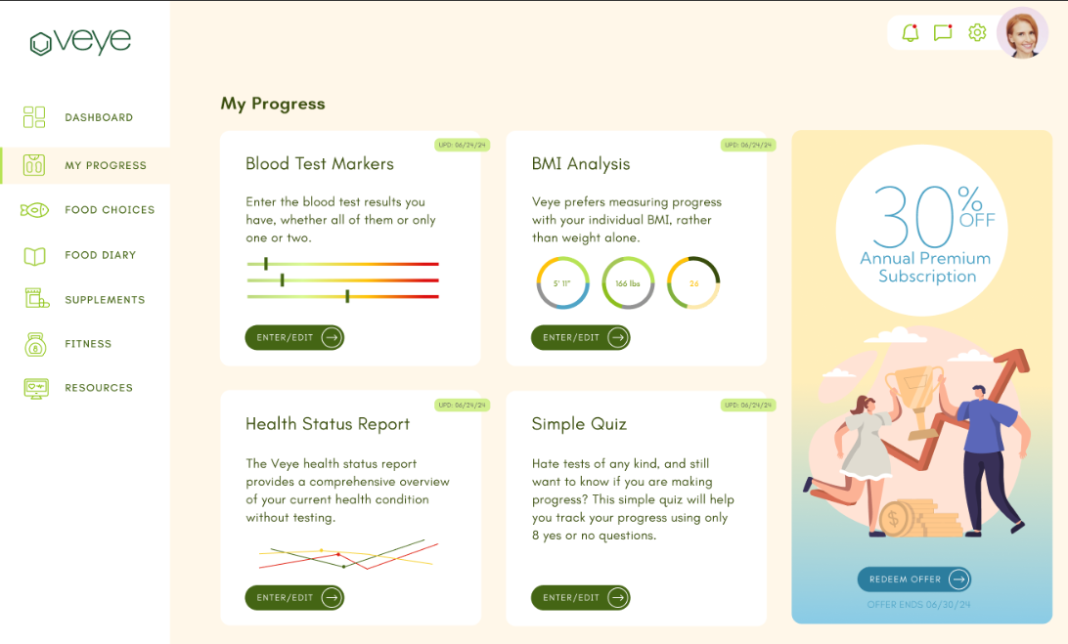

Eventually the dashboard can look like the design, minus the ad at the right for now.

If yes to entering Blood Test Numbers then ideally the Bot takes them to the My Progress tab and opens blood markers for them. (more on the AI experience when I cover Blood Markers in the document. Once the blood markers are in the Bot says “Would you like to do more than one progress tracker? If yes then the Bot starts with would you like to to a BMI analysis, then would you like to fill in the Health Status Report, then would you like to take the Simple Quiz. If no on doing more progress trackers then the Bot says “The next helpful step is filling in the Food Choices” More on that in the Food choices section later in the document.
If no to having blood test results the Bot says “Would you like to do a BMI analysis?”

If yes to the BMI analysis the Bot takes them there. More on the BMI guidance in that section later. Once the BMI is done the Bot says “Would you like to do more than one progress tracker? If yes then the Bot starts with would you like to to a BMI analysis, then would you like to fill in the Health Status Report, then would you like to take the Simple Quiz. If no on doing more progress trackers then the Bot says “The next helpful step is filling in the Food Choices. Can I take you to that section?” More on that in the Food choices section later in the document.

If no to the BMI analysis the Bot says “Many people do not have blood tests available and prefer not to do a BMI. Would you like to take the time do a Health Status Report? It only takes a minutes.

If yes to the HSR the Bot takes them there. When finished, the Bot says would you also like to take the Simple Quiz? If no on doing the Simple Quiz the Bot says “The next helpful step is filling in the Food Choices. Can I take you to that section?” More on that in the Food choices section later in the document.

If no to the HSR the Bot says “I suggest you take the Simple Quiz, just 8 yes/no questions can give you good information on how the program is working for you”

If yes to the SQ the bot takes them there. When finished the Bot says “The next helpful step is filling in the Food Choices. Can I take you to that section?” More on that in the Food choices section later in the document.

When the progress trackers are completed, they show up in the graph at the bottom right of the dashboard as a line graph of the ones used. Unused ones are at rest, and if none are used then all are at rest. Here is the line graph https://docs.google.com/spreadsheets/d/1D-9PFq3KMyFkNtSrCk25o1Vf99MIsYREbIAUfulM3wA/edit?usp=sharing and key:

Blood Markers red
BMI green
Health Questionnaire blue
Simple Quiz orange

If no to the SQ, the bot says, “Would you like to fill in the food choices so I can make personalized suggestions based on the foods you like to eat?”

If yes, then the bot goes to food choices (below starting with #6)

If no, then see this Inro Decision Tree script https://docs.google.com/document/d/1M9zPJiVdeFmWf0_7Q3Arp7-FBIuUIHwr39k8Ir0s4og/edit?usp=drive_link

This is the start of the HOW TO AI training section. https://docs.google.com/document/d/12JkGADJAXLzfrdzKXeykzPxO2MAM6q4lY_9x6ZOe9dk/edit?usp=drive_link

